1. CREATE A SUPABASE ACCOUNT –SIGN IN THROUGH GITHUB
2. NAME THE PROJECT FOR EXAMPLE : “LNG_APP” without quotes.
3. IN PROJECT OEVRVIEW IN LNG_APP FIND ‘PROJECT API’ as shown in snapshot below.

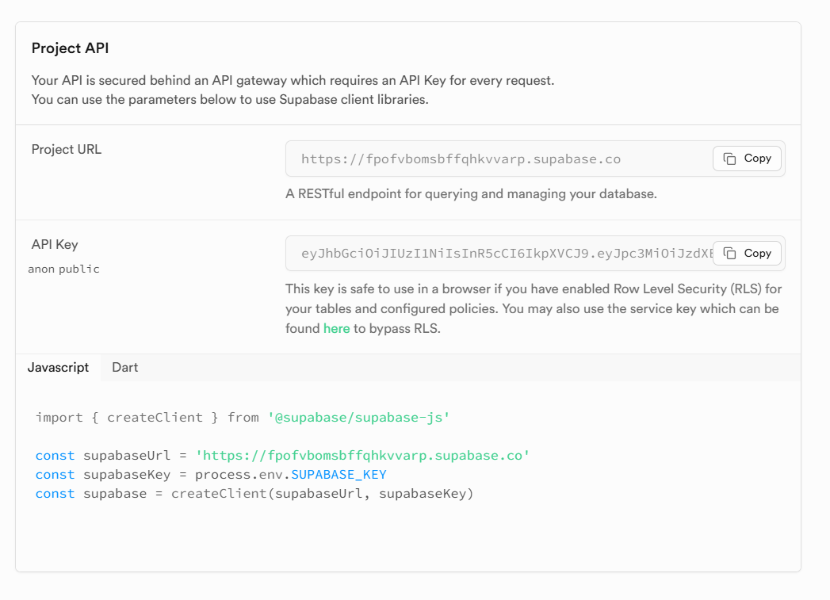

1. The above contains ‘PROJECT URL’ & ‘API KEY’
2. IN SQL EDITOR Create Table with Known or required columns:

Example: Insert SQL query like below without ‘text’ in it, actual column names.

create table tank_data (

  "Date" text,

  "BDN" text,

  "ME_cons" text,

  "F.vap_cons" text,

  "GE_cons" text,

  "BLR_cons" text,

  "ROB_cal" text,

  "ROB_cams" text,

  "Discrepancy" text,

  "Trim" text,

  "List" text,

  "Level_TK1" text,

  "Vap_temp_TK1" text,

  "Liq_temp_TK1" text,

  "Press_TK1" text,

  "Level_TK2" text,

  "Vap_temp_TK2" text,

  "Liq_temp_TK2" text,

  "Press_TK2" text,

  "CH4" text,

  "C2H6" text,

  "C3H8" text,

  "i-C4H10" text,

  "n-C4H10" text,

  "i-C5H12" text,

  "n-C5H12" text,

  "n-C6H14+" text,

  "N2" text,

  "CH4s" text,

  "C2H6s" text,

  "C3H8s" text,

  "i-C4H10s" text,

  "n-C4H10s" text,

  "i-C5H12s" text,

  "n-C5H12s" text,

  "n-C6H14+s" text,

  "N2s" text,

  "CH4c" text,

  "C2H6c" text,

  "C3H8c" text,

  "i-C4H10c" text,

  "n-C4H10c" text,

  "i-C5H12c" text,

  "n-C5H12c" text,

  "n-C6H14+c" text,

  "N2c" text,

  "CH4m" text,

  "C2H6m" text,

  "C3H8m" text,

  "i-C4H10m" text,

  "n-C4H10m" text,

  "i-C5H12m" text,

  "n-C5H12m" text,

  "n-C6H14+m" text,

  "N2m" text,

  "PKI" text,

  "MN" text,

  "Min_MN" text,

  "Molar_Mass" text,

  "Density" text

);

In the above query ‘tank_data’ is the Table or dataset name.

1. If, However, the “incompatible” warning appears it likely means there’s a mismatch between your CSV data and the table schema.

Here’s how to fix it:

**⚙️ Fixing CSV Import Incompatibility**

**✅ 1. Check Column Names**

Make sure the column names in your table match the CSV headers **exactly**, including:

* No extra spaces
* No special characters (e.g., +, .)
* Replace symbols with underscores (_) in SQL

For example:

* F.vap_cons → f_vap_cons
* n-C6H14+ → n_c6h14_plus

You may need to **rename columns in your table** to match the sanitized CSV headers.

**✅ 2. Check Data Types**

Supabase expects each column to match its declared type. For example:

* Date should be date or text if formatted like 1-Apr-25
* NULL values are okay if the column allows null

If you’re unsure, you can temporarily set all columns to text and later cast them to numeric or date.

**✅ 3. Re-import After Adjustments**

Once your table schema matches the CSV structure:

* Reopen the import interface
* Confirm column mapping
* Proceed with import

OR generate a revised SQL schema that matches your CSV headers exactly, with all columns as text to ensure compatibility for the first import? You can then refine types afterward.

Like shown below:

create table tank_data (

"Date" text,

"BDN" text,

"ME_cons" text,

"F.vap_cons" text,

"GE_cons" text,

"BLR_cons" text,

"ROB_cal" text,

"ROB_cams" text,

"Discrepancy" text,

"Trim" text,

"List" text,

"Level_TK1" text,

"Vap_temp_TK1" text,

"Liq_temp_TK1" text,

"Press_TK1" text,

"Level_TK2" text,

"Vap_temp_TK2" text,

"Liq_temp_TK2" text,

"Press_TK2" text,

"CH4" text,

"C2H6" text,

"C3H8" text,

"i-C4H10" text,

"n-C4H10" text,

"i-C5H12" text,

"n-C5H12" text,

"n-C6H14+" text,

"N2" text,

"CH4s" text,

"C2H6s" text,

"C3H8s" text,

"i-C4H10s" text,

"n-C4H10s" text,

"i-C5H12s" text,

"n-C5H12s" text,

"n-C6H14+s" text,

"N2s" text,

"CH4c" text,

"C2H6c" text,

"C3H8c" text,

"i-C4H10c" text,

"n-C4H10c" text,

"i-C5H12c" text,

"n-C5H12c" text,

"n-C6H14+c" text,

"N2c" text,

"CH4m" text,

"C2H6m" text,

"C3H8m" text,

"i-C4H10m" text,

"n-C4H10m" text,

"i-C5H12m" text,

"n-C5H12m" text,

"n-C6H14+m" text,

"N2m" text,

"PKI" text,

"MN" text,

"Min_MN" text,

"Molar_Mass" text,

"Density" text

);

This schema preserves your original header names using double quotes, which is valid in PostgreSQL.

**🔄 Next Steps**

* Run this SQL in Supabase’s **SQL Editor**.
* Re-upload your CSV via the **Table Editor**.
* Once imported, you can:
  + Cast columns to numeric, date, etc.
  + Add constraints or indexes
  + Enable RLS if needed.

If you see error — ERROR: 42P07: relation 'tank_data' already exists — simply means the table tank_data is already present in your database.

**Options to Proceed**

**✅ Option 1: Drop and Recreate the Table**

If you're okay with deleting the existing table and starting fresh:

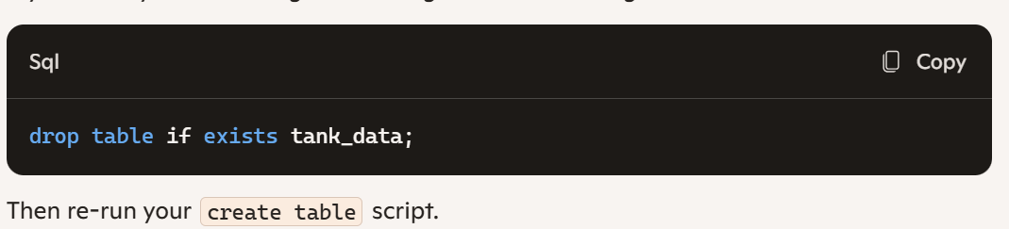

✅ Option 2: Alter the Existing Table

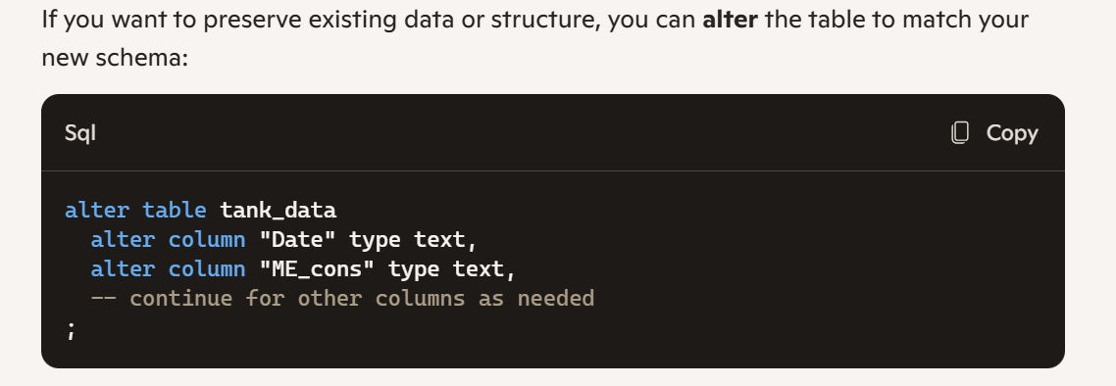

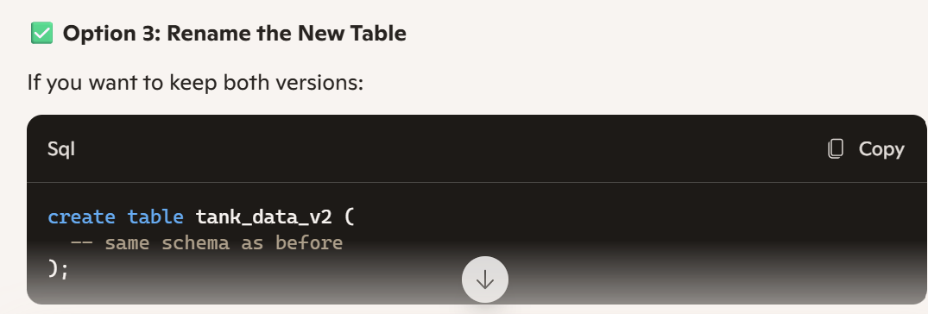

1. Once the table with your columns_text are created, change the dtypes of each as required. Every column has an arrow detent that can be clicked to changed dtypes.
2. Enable RLS. Punch this code in SQL editor.

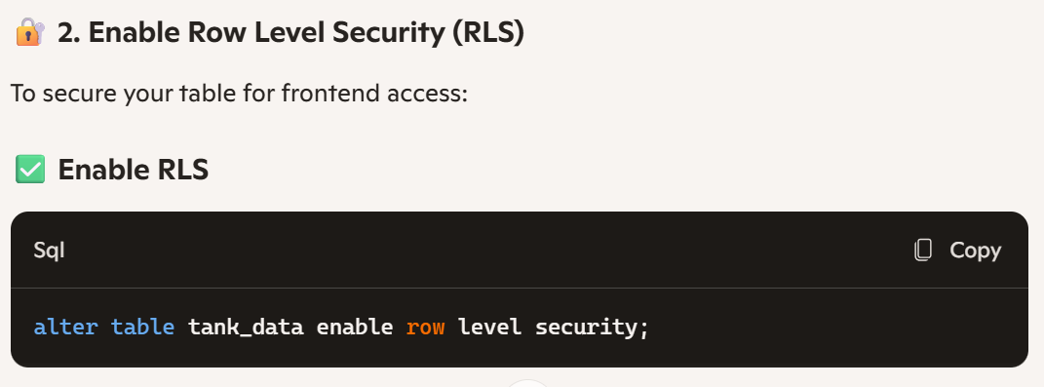

alter table tank_data enable row level security;

1. Punch this code in SQL EDITOR

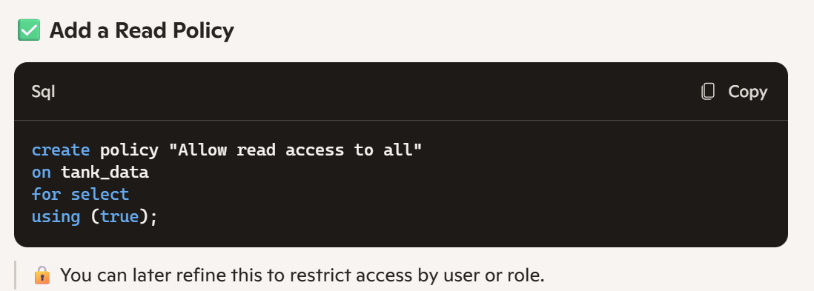

create policy "Allow read access to all"

on tank_data

for select

using (true);

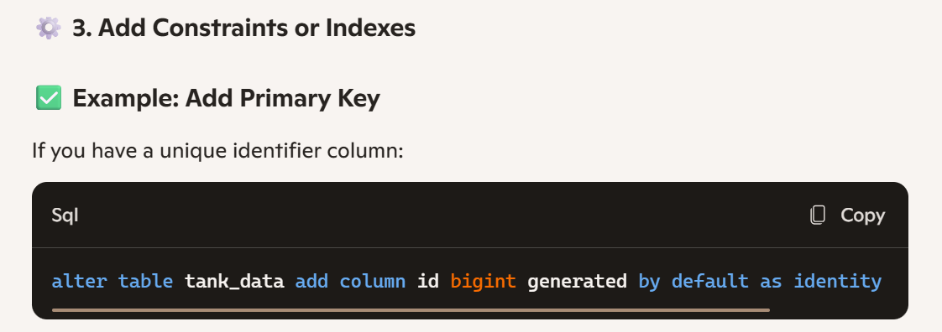

alter table tank_data

add column id bigint generated by default as identity primary key;

1. Convert date to index if required.

